Hong Kong University of Science and Technology

Final Year Project Report
Peer –To – Peer IPTV – TD1a-09


Project Supervisor : Prof. Danny Tsang
Signature : ___________________

conducted by : Cheng Wen Chi, Vinci (07481136)_____________
Chiu Kwok Shing (07323530)________________
Choi Kwok Yam, Alex (07483512)_____________

School of Engineering – BEng of Computer Engineering
Date: 07-04-2010

EXECUTIVE SUMMARY

Nowadays, Internet has become part of our life. Domestic users enjoy various kinds of entertainment online within the high speed network. The introduction of P2P technology also boosts up the performance of Internet application. IPTV is one of the hottest online applications which make use of P2P technology. This IPTV project aims to introduce a P2P IPTV with live HD streaming under a scalable system. The greatest challenge of providing HDIPTV is the network speed and stability of clients’ computer internet connection. To solve these problems, our P2P IPTV system applied hybrid connection model which include the push mode and pull mode on cool streaming model. The hybrid mode model has perfectly delivery the video stream to each IPTV client in our final product. It achieved a HDTV (480p) live TV with multiple broadcast channels under HK internet environment.
Table of Contents
1 Chapter Overview 3
1.1 Introduction 3
1.2 Aim and Objectives 4
1.3 System Block Diagrams 5
1.4 Design Specification 6
1.5 Report Outline 7
2 Background Information 8
3 Methodology 9
3.1 Design Phase 9
3.2 Implementation 9
3.3 Testing 13
3.4 Evaluation...……………………...………………………………………….14
3.5 Schedule of Responsibility………………………………………………….15
4 VLC library......…………….…………………….…………………………….15
5 Server Client Mode Design.……………………………………………….…..16
6 Data Encryption/Decryption........……………………………………..…...…17
7 Sub-streaming and push mode ………………….………………………..….18
8 XML Database ……………….. …………………………………………...…19
9 Tracker server and Multiple Channel ……………….. ……………….……20
10 Connection and Reconnection Handling……………………………………..21
11 Pull-Mode Implementation……………………………………………………22
13 Statistic Application …………………………………………..……………….23
14 Discussion and Conclusion 24

References………………………………………………………………………...…25

Appendices………………………………………………………..……………...…26
- Chapter Overview

  - Introduction

With the development of networking technology, broadband has become more and more popular in the world. According to data and statistics from Office of the Telecommunications Authority (OFTA) [10], the household broadband penetration rate of Hong Kong is reaching almost 77% in May 2008, which is higher than the average standard of developed countries [11]. Having such advance environment, many people have a great thirst on high quality networking multimedia service.
In accordance with the statistic of OFTA in 2009[12], there are 1.08 million IPTV subscribers in Hong Kong at December 2008 which is the highest in the world in terms of household penetration.

Home users demand for higher quality of online video service. YouTube, the most famous video sharing website, has just announced that users now have the option of watching some video in 720p HD, much better than 320x240 fps video in the past.

High-Definition Television (HDTV) technology is commonly used all around the world. Most of them are not broadcast through Internet. While some of them are broadcast through satellite. Since rapid development of network technology, it can make more people view their TV programs through internet broadcast with IPTV.

The two free television providers (TVB & ATV) in Hong Kong start to provide HDTV broadcasting since 31st December 2007.^{[13]} Customer can watch films with resolution not less than 480P. In Europe, the first European HDTV channel starts to broadcast since 2003. Up to end of 2009, there were 114 HD channels broadcasting from Astra satellites ^{[14]}.

In traditional client-server mode, IPTV required a server with high processing power and large bandwidth in order to provide a high quality online video service. Thus, a large investment is required to build high efficient server and network thus makes investor hesitate to start such project.

Peer-to-Peer (P2P) Technology presents a great advantage over the traditional client-server model. In P2P model, clients will work as a part of the service provider when they join into the mesh network, which lower the workload of server. Applying P2P technology, the required network resources from the server will be reduced. Thus, we can provide more users with the same amount of resources. Considering the well developed broadband network in Hong Kong, we can use P2P technology to provide user high quality IPTV.

  - Aim and Objectives

This project is developing a program to examine streaming Internet Protocol Television (IPTV) over peer-to-peer networks with high resolution video. The aim of this project is to investigate the different approaches of P2P video streaming in order to create a low delay, high quality IPTV application, thus different P2P algorithms may be applied, such as pull-based, pure push, hybrid, etc.

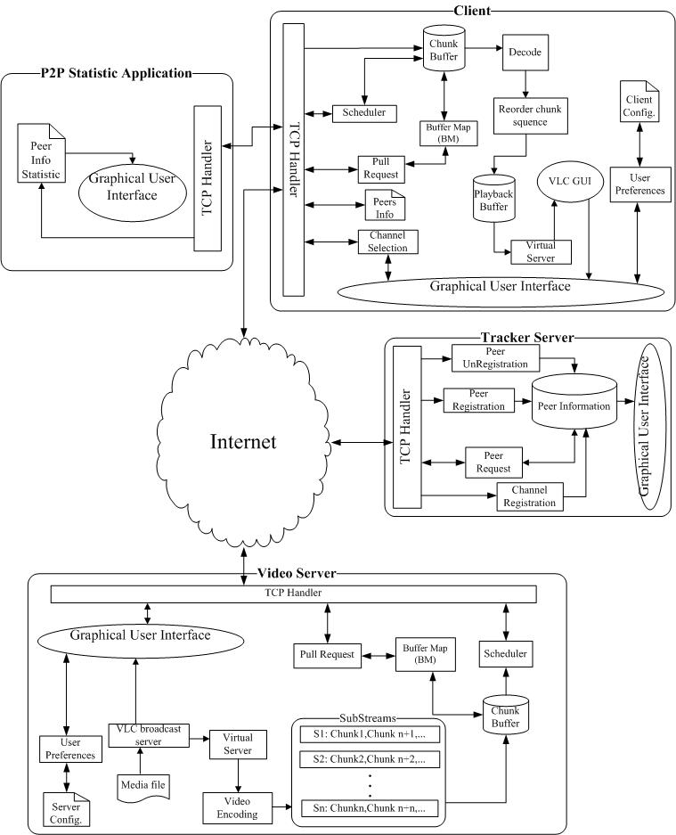
  - System Block Diagrams

Fig.1 – Whole System Block Diagram

  - Design Specification

Component description
Components | Functions
Tracker | The key link of the whole system. It will track and save all peer information that join into the system, included the server and client. All peers will first join into it and register in the peer list, the Tracker server will then return a list of peer information to it.
Server | Contained all the source of video which is the fundamental of the whole system. It will create buffer and encode it to stream out.
Client | Provide a GUI interface to end user to watch the video provide by the system, it will build up a virtual server to stream out decoded video data to the VLC core player
Statistic Application | An application that measure the upload and download speed of the client-side application.

Design Specification
Protocol | TCP, HTTP
3rd parties Library | VLC player API
Supported Video Type | WMV, AVI
Transmitted Data Type | TS
Supported OS | Windows XP, Windows Vista, Windows 7
Supported Video Resolution | 480P or lower (1500 Mbits/s)

  - Report Outline

Chapter 2: Background Information
This chapter is a review of the background materials. This includes the brief introduction on P2P technology and the aim of our project.

Chapter 3: Methodology
3.1.1 Design Phase
This chapter explains the methodology we adopted in this project. Restate the problem looked at and ways that we have taken to solve these problems.
3.1.2 Implementation
State number of stages there were in the project.
3.1.3 Testing
State the tests performed in our project
3.1.4 Evaluation
State and analysis the result obtained.
3.1.5 Schedule of Responsibility
Gantt chart and a task list with a clear summary of the responsibilities of each member of the Team.

Chapter 4: VLC Library Implementation

Chapter 5: Server Client Mode Design

Chapter 6: Data Encryption / Decryption

Chapter 5: Server Client Mode Design

Chapter 6: Data Encryption / Decryption

Chapter 7: Sub-streaming and push mode Implementation

Chapter 10: Discussion and Conclusion

Discuss the result we obtained, discuss the relation of them and verify it.
Then briefly restate the problem we looked at, and the methodology to solve it.

- Background Information

P2P model is widely used for file or data sharing in modern internet. In P2P model, clients become participators in the data upload. The transmission speed is no longer based on the server throughput (server-client model), but determined by the throughput of both the peers and the server. Theologically, the performance of P2P network will be even improved with the increased number of peers. The bandwidth of client computers have increased rapidly in the past few years, thus optimizing the working environment for P2P model. The workload and dependence of server throughput is also reduced by P2P model. As a result, much stable and high data throughput can be achieved in the same topology.

Entertainment has become the main function of the home PC. Online Movie, TV, music are common home entertainment. Users enjoy different kinds of online entertainment through their broadband connection in different countries. Most of the online multimedia applications need to deliver a large amount of time sensitive data. The multimedia streaming leads to a significant problem for server to deliver a stable service to large number of clients. P2P model then became one of the most feasible solutions for multimedia data delivery. IPTV is a signification example of multimedia streaming those benefits from the P2P model. In the past, it is impossible to deliver real time TV broadcast through the internet. The throughput of the server did not meet the needs of client for high bit rate in the client-server model. However, after P2P model is applied, the throughput of the downloaded stream in each client has significantly increased, and the data streaming is then allowed to support the high bit rate of the video. As a result, most of the popular P2P IPTV systems use P2P model to provide their service.

High and stable throughput of the data streaming is critical factor in P2P IPTV performance. The construction of P2P streaming network is the most important for P2P IPTV, as it will drive the performance of data streaming.

There are two major design considerations in the construction of a P2P streaming network:
- forming an overlay topology between peers
- delivering video content efficiently
According to the researches papers [3] [4], there are two common basic approaches to construct P2P network, mesh pull and tree push. For tree push, peers are connected in tree-shaped overlay and video data is pushed out from root (server) to peers by passing through the tree hierarchy. For mesh pull, peers form a mesh-shaped overlay and they pull video from each other by sending request to a peer.

Recently, there are numbers commercial P2P IPTV has been successfully deployed. According to articles [1][2], those IPTV users are increased exponentially in these few years. PPStream, PPlive, SopCast are examples of common P2P IPTV. Most of them apply the mesh pull algorithm to deliver the service, and TCP to ensure the reliability of delivery. The mesh-pull system is popular for P2P IPTV as it is relatively a simpler design principle than tree push. However, they demonstrated some common problems, such as large initial delay, high reconnection latency and high disconnection rate.

In this project, our aim is to implement a high quality and stable IPTV system with a optimize P2P model. The academic papers [4] indicate tree-push provides a better performance in practice. Tree push causes a lesser overhead in data streaming over mesh pull and it will be further discuss in the methodology section of this report.

Tree push system will be deployed as the core of our project, and then enhanced the system performance with several algorithms. These algorithms include multiple trees model, data sub streaming, and pulling algorithm. The approach to implement these algorithms will also be clarified in the methodology section of the report.

- Methodology

3.1 Design Phase

Description of the Proposed Solution
Hybrid-Mode architecture
Bearing strong similarities to BitTorrent, mesh-pull streaming deviates significantly from BitTorrent in various aspects [3]. The mesh-pull systems apply a simple design principle and suitable for high dynamic, high-churn P2P environment [5].In Mesh-pull streaming, the host exchange the Buffer Map [7] and retrieve the missing chunks. Every chunk has a playback deadline, so video chunk scheduling algorithm is indispensable. Gossip based peer search algorithm is implementing in mesh-pull system to support large-scale group communication. However, gossip algorithm incur various implications, i.e. delay may occur in searching peer; tracker server may only handle part of peers in the system and lose the global view of the network[3].Another, mesh-pull systems always suffer from high traffic overhead, long start-up delays, video channel switching delays and peer playback time lags[3].

Tree-push architecture: Tree-push systems may achieve high throughput, low overhead, fast start-up time and small delay, if the tree structure does not break down due to peer churn and peers at the higher level of the tree have sufficient upload capacities to support streaming for their children peers [6] Another, tree construction mechanism can optimize the tree so as to reduce stress on the underlying network. In tree-push streaming, peers share the video chunk to their children peers immediately. Buffer Map [7] and retrieved missing chunks will not apply in this streaming system.
However, the tree-push system is instability. When one node is losing, such event affects all other nodes below its hierarchy.

In this project, tree-push will be used to develop the overlay topology. Tree-push provides smaller delay time of video playback when compare to mesh-pull. This advantage is appropriate for IPTV but tree-push is instability. Therefore, we enhance the system performance with several algorithms to minimize the instability. Multiple trees and sub streaming will be applied into the tree-push. Sub streaming divide video stream into different sub-stream with equal sizes, and each sub-stream is assigned a sequence number to represent its play black order in the stream [8]. Each sub-stream use separate tree to broadcast. Peers join as many trees as three are sub-streams they want to receive. Another, we will implement Multiple Descriptions Coding (MDC) to improve the video play back quality. MDC constructs multiple independent multicast trees, one for each sub-stream. A peer can improve its media quality by joining more multicast trees under the constraint of its download link capacity. More importantly, the departure of one ancestor in a multicast tree does not severely degrade the media quality of a peer, since it can still receive the majority of sub-streams from other multicast trees [9].

Technical Challenges and Merits of the Project
In the project, we encounter numbers of technical challenges during development:
1. The lagging problem of video playback
Solution: Buffer is added in the receiving network thread. Buffer accumulates a small number of data chunks before playback in local VLC player start. When the data chunk in buffer is below certain amount, the playback will be PAUSE until the received data accumulate to certain level again. By this approach, the cases of continuous lag are reduced when the download bandwidth is unstable.
2. Different clients have different playback performance on same video source which due to variation of their bandwidth
Solution: provide a system to test the bandwidth of each client. Build a suitable size local buffer for network sub stream and video playback as to ensure the quality of delivery video
3. The system use a lot of CPU processing power even the video stream is stopping. The problem is mainly cause by the thread of network stream
Solution: add the thread sleep inside the endless loop of network stream thread
4. Dead of video playback after applied the video sub stream in multiple trees topology. The problem is caused by incorrect reconstructing of playback video stream.
5. After applied the sub stream delivery of video data chunk, delivery of data chunk are disordered. It leads to problem on reconstructing the original video stream for playback in peers.
Solution: A sequence number is given to each data chunk. When Peer receive data chunk from different sub stream in each thread, data stream will put into buffer of each thread. A distinct thread which responsible for merging sub stream will reordering the data chunk and put them to the playback buffer according to data chunk sequence number.
There are 2 main Metris in this project. This project provides the practical implementation details of tree push model P2P. It gives a well demonstration on applying tree push model for P2P IPTV system. This will helps to promote the tree push model for commercial P2P IPTV system. Besides, MDC is another valuable part of this project. In this few years, MDC (multiple description coding) is started to apply on video streaming over internet. Different video encoding standards are also using MDC Video as algorithm bases. However, researches focus on applying MDC to P2P video streaming model is limited. Our FYP will provide a feasibility review by the experimental implementation of MDC and P2P video streaming.

Deliverables
The final goal of our project is to deliver an efficient and stable P2P IPTV system. The final product should be implementing on tree push bases which include several of enhancements on video streaming, for example sub stream, MDC, etc. The demonstration of product will provide a completed P2P IPTV system which include video server, tracker server and support large number of client peers. It will able to deliver a smooth and small delay live video streaming to every peer in the system. Moreover, it provides a stable services under unfavorable condition such as unstable bandwidth and continuous disjoin and rejoin of peers in the P2P TV system.

3.2.2 Implementation Phase
The ultimate target of our project is to build up an application that can provide QOS IPTV under P2P model.
We can divide our work in the past few months into 5 states.
States | Details
State 1 | One-to-One Client-Server Model Video Streaming Implementation and Testing.
State 2 | One-to-Many Client-Server Model Video Streaming Implementation and Testing
State 3 | Cool Streaming Implementation and Testing
State 4 | Implementation of Multiple level tree structured P2P Network with Tracker Server
State 5 | Further enhancement on sub stream. E.g. MDC, hybrid mode streaming

3.2.3 Testing Phase
To test the functionality and correctness of our system, we have applied different tests within different States, find out the weakness and improve them.

Implementation Test-1
Title: Connectivity Test
Purpose: Confirm the protocols and the system working properly both in wired and wireless network.
Methods: 1. Load the application into different computer, one of them act as Server, others are clients.
2. Set up the system, connect them through wired and wireless network respectively, and mark down any abnormal behavior of the application.

Implementation Test-2
Title: CPU Resources Consumption Test
Purpose: Find out the CPU resource that consumed by the application
Methods: 1. Set up the system, and start the Windows Task Manager, mark down the initial CPU usage that shown in Performance tag.
2. Start the system, mark down the CPU usage during Video Streaming under different condition.

Implementation Test-3
Title: Quality of Service (QOS) Test
Purpose: Test the video quality and application’s performance
Methods: 1. Set up the system, prepare video files with different bitrates
2. Stream out the videos in the system, check and mark the video quality and system stability with different condition, see if there’re any packet losses or delay is out of our acceptance range.

3.2.4 Evaluation Phase
Since the system is still under construction. Purposes of most implementation tests are designed to improve the system.

For the “Test-1”, we have tested connection behavior of our applications under different condition – connect through wired / wireless network, LAN / Internet. Mark down the conditions that will cause disconnection and then update the program to solve the problem.

For the “Test-2”, check the amount of CPU resources that will draw by our applications during running. Review the source code, optimized the codes to reduced the CPU resources consumption.

For the “Test-3”, check the QOS of the system, and track the operation of the applications, examine the condition that can provide the best QOS by the system. Update the source code to improve the QOS of the system.

3.3 Schedule of Responsibilities
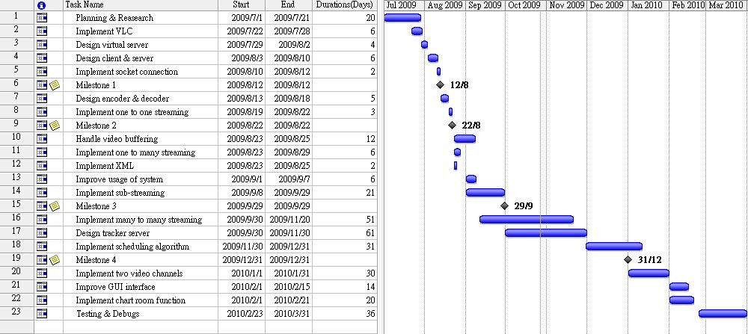

Milestones 1: Client connects to server and requests the data packet
Milestones 2: Client can playback the streaming video through one to one broadcasting.
Milestones 3: One to many broadcasting and using sub-streaming method.
Milestones 4: Showing basic P2P IPTV system.

Responsibility of each Task:
Name | Task Number
Cheng Wen Chi | 1,4,8,10,11,13,17,18,20,22,23
Chiu Kwok Shing | 1,2,12,16,18,20,21,23
Choi Kwok Yam | 1,3,4,5,7,8,11,13,14,18,20,23

4 VLC library
5 Server Client Mode Design
6 Data Encryption/Decryption
7 Sub-streaming and push mode
8 XML Database
System Library Development
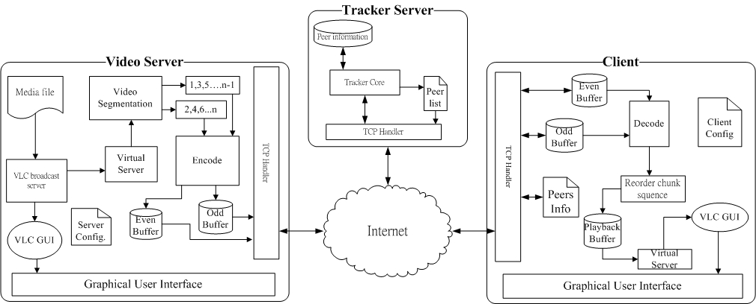

Many settings and users’ preference will be modified frequently instead of hard coded them into the system, such as start buffer size, tracker IP address, and maximum peers’ number, etc. We design a GUI page for user to set need to be set or changed within the system depends on various conditions. We design a GUI page for user to set/modify specific settings.

To store these setting and data, I develop a program to convert these data into XML file format. XML file can be view and edit easily which provide us great convenient for revise purpose.

We obtain the data that we are going to store from the GUI interface, then we using the program to convert these data into a XML file format, we just need to load that XML with the program while we need to attain those data again.

- Implement XML Peer List
In this P2P IPTV system, peer information is stored in XML (Extensible Markup Language) files. XML file type is a set of rules for encoding documents electronically. It provides an open standard which supported in different programming language and platform. In Visual C#, there is a build in library which allows software developers to access XML data, and several schema systems designed to aid in the definition of XML-based languages.
XML simplify the access of peer data. Client computer will not need to install external database management system (DBMS) such as Oracle or MySQL to support the P2P system. This helps to reduce the operation cost of the client system.
9 Tracker server and Multiple Channels

- Implementation of tracker server
The maintenance of many-to-many connection is one of the most important parts in a P2P system. When new peer join into a P2P network, it needs information of other peers in the topology. This information includes the peers’ IP address, service port, bandwidth, etc. The new peer will select peers based on this information for the new connection. Thus, it will build its connectivity with different peers and download the data from them under the P2P model.
Tracker is the sub system which dominates the connection establishment processes. Tracker server is a centralized database which maintains complete record of peer information. It responds to maintain the topology of the P2P IPTV network and provide the accurate peers’ information to every peer in the topology.
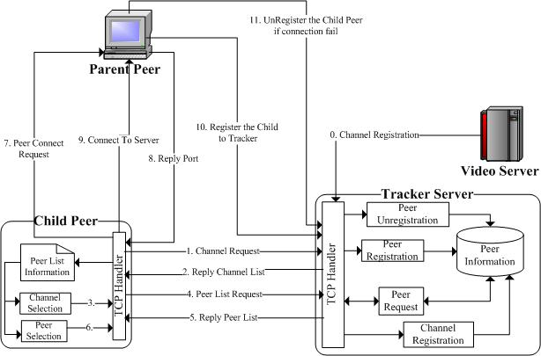
Figure 4.1 Tracker Operation model in P2P IPTV system
In our P2P TV system, tracker server has the identical function with other trackers in different P2P systems. It maintains and provides the channels, servers and peers information. It provides 4 main function, channel registration, peer list request, peer registration, peer deregistration.
The P2PTV system is started by the registration of stream server. When a stream server registered tracker server, a new broadcast channel is established. The registration message defines the channel details include channel name, server IP address and channel number. Tracker server will then create a new peer list for each tree and maintain the information in the channel.
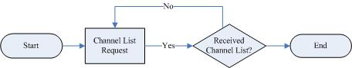
Figure4.2 Flow Chart of channel information request
In Figure 4.2, it shows the flow of channel list request. When a new client joins the P2P TV system, it needs to select a broadcast channel from the channel list. The channel list is retrieve by client program automatically. Client is then choice one of the TV channel to join in.
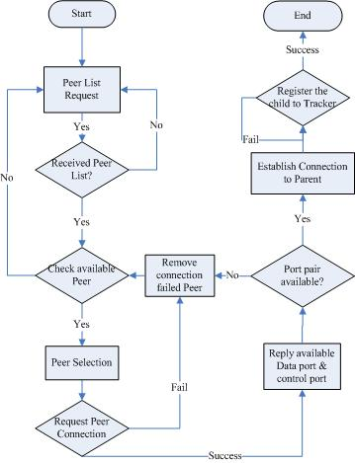
Fig. 4.3 Flow Chart of Peer registration
After the new client selected the channel, it will request a peer list from the tracker for each tree. In the cool streaming model, each tree will provide different sub stream, and client will need an individual connection in each tree. If the peer list from tracker is valid, client program will then select a peer from list for each new connection.
In our system design, the registration and deregistration processes are operate by parent peers. Parent peers are P2P peers which stream the tree data to its child. The tree data are streaming under individual TCP socket to each client. When a parent peer is selected by a child, the child will send a request for the data streaming port and control port. Child peers will establish a new connection on those TCP ports with parent peer. If the connection is started successfully, parent peer will receive the peer id and IP address of each connected child. By using the child information, parent will able to register its child peers to the tracker by registration request. When a peer is register in the tracker, tracker stores the child node information which is linked to its parent node. This information is used in other process, such as peer list request and deregistration of peer.
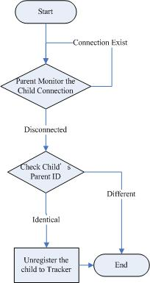
Fig. 4.4 Flow chart of deregistration
For deregistration (Fig. 4.3), parent peer will keep check the alive of TCP connection between its child. When a peer is disconnection with its parent, its parent will send a deregister message to tracker based on child id and tree id which store locally in child connection process. When the tracker received the deregister message, it will match the id of both parent and child before remove the peer from the peer list in the tree. This will avoid the incorrect registration of

10 Connection and Reconnection Handling
11 Pull-Mode Implementation
13 Statistic Application
Peer- To- Peer Statistic tools Development.

This is an application that designed to monitor the upload and download speed of the client application, so the result can be utilized to investigate the performance of the P2PIPTV application’s performance.

It will plot line chart continuously to show the latest upload and download speed respectively, and keep a log to mark the recorded time and recorded speed. So user can investigate the client side application performance with the data collected.

Amount of average download and upload speed and total packet pulled are show at the right button corner of the application. User can view the overall performance of client-side application’s upload and download speed. The total number of packet obtained through pulling algorithm let us know the efficiency of pull mode in the whole system.

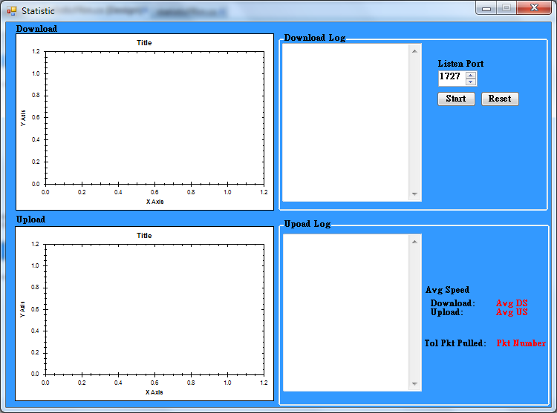
Fig. GUI of Statistic Application

Peer- to- peer Statistic tools Development.

To investigate the performance of our system, it required an application to measure the network speed of the upload and download speed of the client application.

As a result, we start to develop a plug-in for client-side application to measure the upload and download speed of the client application.

For the application development, it contains two main components:
- Graph interface to connect the client-side application and statistic tool
- Statistic tools application with Graphical user interface.

Since we want to make use the information that tracked by the application to make further analysis, we will develop a show the result with a graph interface.

We develop the tools with the help of an open source library called “Zedgraph”, it’s a set of classes that written in C# to create 2D graph. It with high flexibility for user to self-modified the contents of graph.

To enhance the clearness of expression, we will show the data in a dynamic line chart to show the latest result on the graph. The GUI of the application is shown as follow:
14 Discussion and Conclusion

Reference
[1] Laurie Gonzalez, Marketing Director of the Broadband Forum Asia, “IPTV DEPLOYMENTS DOUBLE FOR THE SECOND YEAR RUNNING AS BROADBAND CONTINUES TO ACHIEVE STRONG GROWTH”, 15 July 2008
http://www.broadband-forum.org/news/download/pressreleeases/2008/IPTV_Deployments_Double07_15_08.pdf
[2] Internet Protocol Television (iPTV) - Global Strategic Business Report, Global Industry Analysts, Inc., March 2008, Pages: 458 http://www.researchandmarkets.com/reportinfo.asp?report_id=347969&t=t&cat_id=
[3] Xiao jun Hei, Yong Liuz and Keith W. Ross:” IPTV over P2PStreaming Networks: the Mesh-pull Approach”, Communications Magazine, IEEE, Vol. 46, No. 2. (2008)
[4] ZhenjiangLi, YaoYu, XiaojunHei, and Danny Hin-Kwok Tsang: “A Uniﬁed Framework for Sub-stream Scheduling in P2PHybrid Streaming Systems and How to Do Better?”, P. 728-741, 7th May 2009
[5] F. Pianese, D. Perino, J. Keller, and E. W. Biersack, “PULSE: An adaptive, incentive-based, unstructured P2P live streaming system,” IEEE Trans. On Multimedia, vol. 9, no. 8, pp. 1645-1660, Dec. 2007
[6] Li, Z., Yu, Y., Hei, X., Tsang, D.H.K.: “Towards low-redundancy push-pull P2P live streaming”. In: Proc. ICST QShine, Hong Kong (July 2008)
[7] Xiao jun Hei, Chao Liang, Jian Liang, Yong Liu, Keith Ross: “A Measurement Study of a Large-Scale P2P IPTV System”. In Polytechnic University, NY, USA.
[8] Susu Xie, Bo Li, Gabriel Y. Keung, and Xinyan Zhang: “Coolstreaming: Design, Theory, and Practice “, IEEE TRANSACTIONS ON MULTIMEDIA, VOL. 9, NO. 8, DECEMBER 2007
[9] Alexandro SENTINELLI, Luca CELETTO, Damien LEFOL,Claudio PALAZZI, Giovanni PAU, Theodore ZAHARIADIS, Ahola JARI: “Survey on P2P Overlay Streaming Clients”, towards the Future Internet G. Tselentis et al. (Eds.) IOS Press, 2009
[10] Broadband Consumer Education Programme, Office of the Telecommunications Authority (OFTA) - HKSAR, 11 September 2008
http://www.ofta.gov.hk/en/ad-comm/ucac/paper/uc2008p6.pdf
[11] Source: Gartner, Science & Technology Policy Research and Information Center , July 2008
http://cdnet.stpi.org.tw/techroom/market/eetelecomm/2008/eetelecomm_08_033.htm
[12] Hong Kong: The Facts, Published by the Information Service Department – HKSAR OFTA, April 2009
http://www.gov.hk/en/about/abouthk/factsheets/docs/telecommunications.pdf
[13] Estimated Coverage of Digital Terrestrial Television ( Jan 2010)
- Commerce and Economic Development Bureau - HKSAR
http://www.digitaltv.gov.hk/general/pdf/coverage.pdfx

[14] Astra Satellite Monitor survey - SES-Astra Presentation March 17, 2010
http://www.ses-astra.com/business/en/news-events/news-latest/index.php?pressRelease=/pressReleases/pressReleaseList/10-03-18/index.php

- Appendices
Minutes of the 1st FYP Meeting
Date : 1/6/2009
Time : 10:30AM
Place : Room 2421
Attending : Prof. Danny Tsang,
Cheng Wen Chi, Chiu Kwok Shing, Choi Kwok Yam
Absent : None
Recorder : Chiu Kwok Shing

1. Items discussed
1.1. Recommended Schedule of the project
1.2. Recommended Protocol
1.3. Possible barriers
1.4. Reference P2P protocol

2. Problems/questions
2.1. What’s the first target of our project?
Conclusion: Develop an one-to-one client-server mode video streaming model.

2.2. Packet division / sending protocol and video encoding / decoding protocol
Conclusion: Investigate the possibility of applying VLC plug-in library.

2.3 How to apply VLC library?
Conclusion: Using C# as the developing language instead of C++, further investigate the implementation method by our own.

2.4 Does there any recommended papers for P2P IPTV?
Conclusion: Cool-streaming is recommended for reference.

3. Action items/tasks
Start working on Milestone 1 – Develop a one-to-one client-server mode video streaming model.

4. Date and time of next meeting
Next meeting will be held at the June-mid, further details of meeting date and time will be confirmed later by email.

5. Meeting adjournment
The meeting was adjourned at 11:30AM.

Minutes of the 2nd FYP Meeting
Date : 23/7/2009
Time : 3:30PM
Place : Room 2421
Attending : Prof. Danny Tsang,
Cheng Wen Chi, Chiu Kwok Shing, Choi Kwok Yam
Absent : None
Recorder : Chiu Kwok Shing

1. Items discussed

1.1. Report the current progress
Finish the target tasks that set in the 1st FY P meeting, 1-to-1 client-server mode video streaming model was set up.

1.2. Recommendation from Prof. Danny Tsang
Redevelop the system with VLC plug-in library instead of Windows Media Player plug-in.

1.3. Possibility of Implement MDC on our system

2. Action items/tasks
Implement the 1-to-many client-server mode video streaming model.

3. Date and time of next meeting
Next meeting will be held at the end of summer holiday, further details of meeting date and time will be confirmed later by email.

4. Meeting adjournment
The meeting was adjourned at 4:30PM.

Minutes of the 3rd FYP Meeting
Date : 8/9/2009
Time : 4:30PM
Place : Room 2421
Attending : Prof. Danny Tsang,
Cheng Wen Chi, Chiu Kwok Shing, Choi Kwok Yam
Absent : None
Recorder : Chiu Kwok Shing

1. Items discussed
1.1. Report the current progress
Finish the task set in 2nd FY P meeting, the system can stream out the video from server to multiple users.
1.2. Recommendation from Prof. Danny Tsang
1.3. How to make the streaming data into sub-streamming.

2. Action items/tasks
Implement sub-streaming to the 1-to-many client-server mode video streaming model.
Divide the server into Main server and Video Server.

3. Date and time of next meeting
Next meeting will be held at next month, further details of meeting date and time will be confirmed later by email.

4. Meeting adjournment
The meeting was adjourned at 5:30PM.

Minutes of the 4th FYP Meeting
Date : 15/10/2009
Time : 4:30PM
Place : Room 2421
Attending : Prof. Danny Tsang,
Cheng Wen Chi, Chiu Kwok Shing, Choi Kwok Yam
Absent : None
Recorder : Chiu Kwok Shing

1. Items discussed
1.1. Report the current progress
Finish the tasks that set in the 3rd FYP meeting.
1.2. Recommendation from Prof. Danny Tsang
1.3. Possibility that apply MDC on our system
Implementation on MDC will be further discussed by Prof. Danny Tsang and TA, recommendation and guidance would be given if they made a conclusion.

2. Action items/tasks
Develop a feasible P2P algorithm to our system; convert the system from client-server model to P2P model.

3. Date and time of next meeting
Next meeting will be held at next month, further details of meeting date and time will be confirmed later by email.

4. Meeting adjournment
The meeting was adjourned at 5:15PM.

Minutes of the 5th FYP Meeting
Date : 22/12/2009
Time : 4:30PM
Place : Room 2421
Attending : Prof. Danny Tsang,
Cheng Wen Chi, Chiu Kwok Shing, Choi Kwok Yam
Absent : None
Recorder : Chiu Kwok Shing

1. Items discussed
1.1. Report the current progress
Finish the tasks that set in the 4th FYP meeting.
1.2. Recommendation from Prof. Danny Tsang
1.3. Add a tool to monitor the peers, draw graph to make statistics.
1.4 Disconnection selection improvement, parent selection while reconnection.
1.5 MDC will not be applied into the project due to technical issue and short out of time.

2. Action items/tasks
Applied Pull-mode P2P streaming into the system to make it run as Hybrid Mode.
Add a statistic tool to record the network behavior.
Enhance the Graphical User Interface.
Prepare a demo on our system in the next meeting.

3. Date and time of next meeting
Next meeting will be held at beginning of February, further details of meeting date and time will be confirmed later by email.

4. Meeting adjournment
The meeting was adjourned at 5:15PM.

Minutes of the 6th FYP Meeting
Date : 10/2/2009
Time : 4:30PM
Place : Room 3117
Attending : Prof. Danny Tsang,
Cheng Wen Chi, Chiu Kwok Shing, Choi Kwok Yam
Absent : None
Recorder : Chiu Kwok Shing

1. Items discussed
1.1. Report the current progress
Finish the tasks that set in the 5th FYP meeting.
1.2. Demonstration in the laboratory
1.3. Recommendation from Prof. Danny Tsang

2. Action items/tasks
Avoid looping while reconnection and multi-channel will be applied into the project.

3. Date and time of next meeting
Next meeting will be held at next month, further details of meeting date and time will be confirmed later by email.

4. Meeting adjournment
The meeting was adjourned at 5:15PM.

